Olé! Wanda Barcelona’s ‘Fantastico’ Celebrates ICFF, Language of the Fan
May 22, 2013 1:22 PM
The W New York Hotel Union Square helped ICFF celebrate its 25th anniversary with an exotic installation imported from Spain. We equipped writer Nancy Lazarus with castanets and asked her to survey the scene.
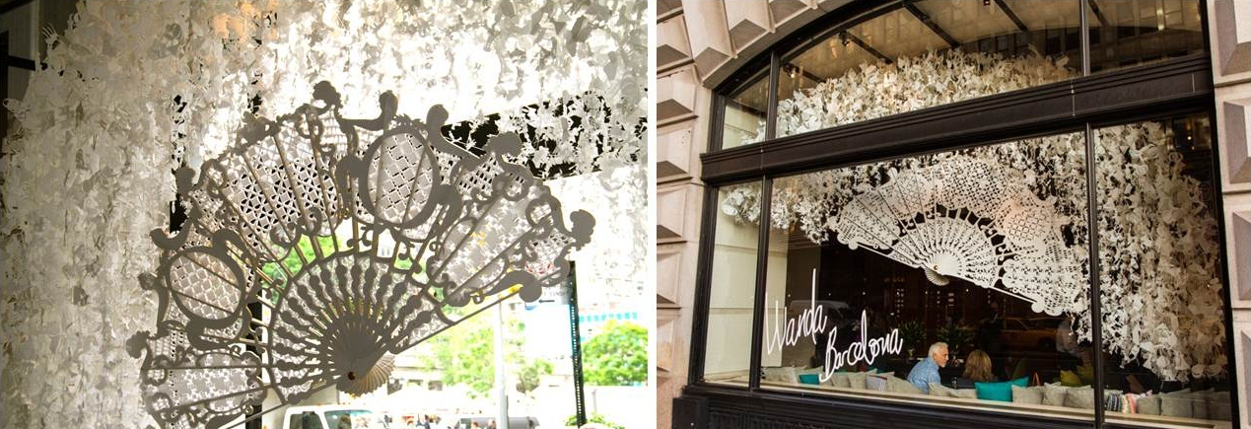
(Photos courtesy W Hotel Union Square)
Wanda Barcelona is heading back to Spain with many new fans. The design firm, which specializes in “paper dreams, ephemeral architecture, and creative spaces,” created “Fantastico” (above) for display at the W New York Union Square during ICFF. The enormous yet graceful wooden fan with intricate paper cutouts celebrated the history of furniture design, the Spanish “language of the hand fan,” and the recently completed renovation of the W hotel property.
During a Monday evening event at the hotel, the trio from Wanda Barcelona (below) was on hand to shed light on their fantasy construction, created with the support of Interiors from Spain. Inti Velez, the firm’s architect, said the fan structure was inspired by the way “high-society Spanish girls used to communicate with their lovers during Spanish colonial times.” For example, fanning very quickly meant they were engaged. Velez noted that it reminds him of today’s rapid text-message exchanges.
The name “Fantastico” not only conveys hand fans and fantasy, but also translates well into English, Spanish, and other Romance languages, noted Dani Mancini, the firm’s designer. He said they used white along with gold accents to “capture the feeling of elegance and to fit well into the new décor of the W Hotel’s lobby.”
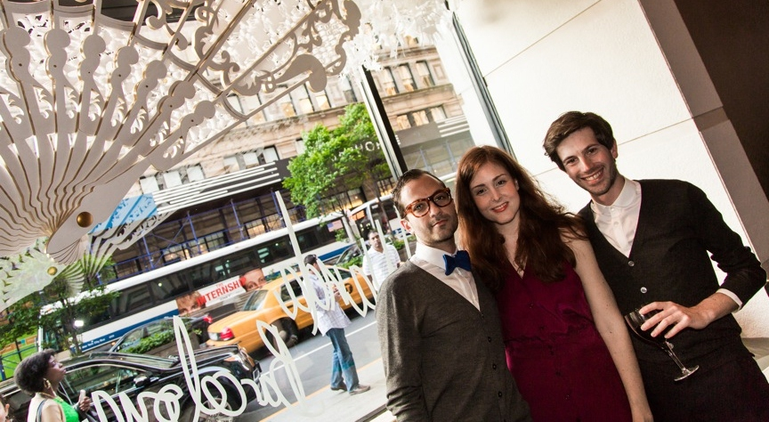
From left, Inti Velez, Iris Joval, and Dani Mancini of Wanda Barcelona.
The fan contained 6,000 cutouts in 11 different designs. Those included “classic and contemporary furniture such as chairs and lamps, as well as Lladro-inspired patterns,” said Iris Joval, the firm’s artist. “Fantastico” took over a month to design and fabricate, using drawings and 3D imaging, Mancini added.
Though the installation was temporary, it will live on through social media platforms such as Facebook and Instagram, where some gestures from the language of the fan would fit right in: holding the fan with the right hand in front of the face means “follow me,” and leaving the fan hanging means “we will continue to be friends.” Unfortunately there’s no official hand-fan signal to request that the piece remain on view longer.
Nancy Lazarus’s is a contributor to UnBeige.

